Temasek Polytechnic
School of Informatics and IT

Diploma in Information Technology (IT)

Software Design Specifications (DS)

Project Particulars
Tutor | Miss Ho Li Chin
Class | P01
Project Title | Delonix Regia Hotel Management System

Project Team’s Particulars
Matric Number | Student Name
1405307H | Celine Neo Shi Ling
1401529A | Chen Yee Yin (Andrea)
1406183B | Ong Jing Hui Rachael
1402047C | Serena See Lee Ping

Table of Contents

1. DISTRIBUTION OF WORKLOAD 3
2. ARCHITECTURE DESIGN 3
3. USER INTERFACE (UI) DESIGN 5
4. PROGRAM DESIGN 17
5. DATABASE DESIGN 24

DISTRIBUTION OF WORKLOAD

Design | Members
Architecture Design | Celine Neo
User Interface (UI) Design | Andrea Chen
Program Design | Serena See
Database Design | Rachael Ong

ARCHITECTURE DESIGN
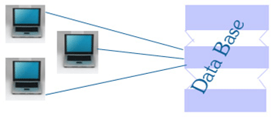 | 2 - Tier Architecture
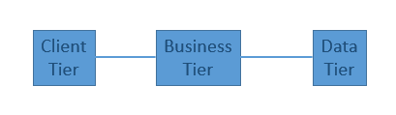 | 3 - Tier Architecture

Client Tier:
Contains the user interface for the application. This is used for the design purpose where data is presented to the user and/or input is taken from the user.

Business Tier:
All business logic is written here. This tier acts as an interface between Client layer and Data Access Layer. Also called the intermediary later, it helps to make communication faster between client and data layer.

Data Tier:
his layer contains methods to connect with database to perform CRUD from the data based on the input data.

 | Advantages | Disadvantages
2 – Tier Architecture | Easy to maintain  Faster Communication | Performance decreases with increasing users  Cost-ineffective
3 – Tier Architecture | High/Better performance  Scalability  Performance – because the presentation tier can cache requests, network utilization is minimized, and the load is reduced on the Application and Data tiers.  Higher Flexibility  Better Re-use  Improved Data Integrity  Improved Security  Easier to maintain and modify, and will not affect other modules | Increased Complexity/Effort

Decision:
Decided to use a 3-tier Architecture design as there are more advantages and less disadvantages. Also, having a 3 tier Architecture is easier to modify, and should the application’s area of use be expanded, there is better Security, Data Integrity and performance compared to a 2-tier Architecture.

USER INTERFACE (UI) DESIGN
Existing Forms of User Interface
There is a very diverse range of user interface types, but in this section we will be focusing on the more commonly used ones, which are web user interface and graphical web user interface. Let us now have an insight on what each is about:
- Web User Interface
Web-based user interfaces take in user inputs and provide output in the form of web pages which are transmitted via the internet. The user will then be able to view these pages with a web browser program (Internet Explorer, Google Chrome, Mozilla Firefox, etc.)
With this interface type, users have the ability to configure and manage the server appliance from a remote client. The web UI is an HTML-based application and with an extension, users can be confident in achieving a consistent, reliable and extensible user interface.

- Graphical User Interface
The graphical user interface is an interaction style between the user and computer, based on the most fundamental components: Windows, icons, menus and pointers. Users are granted with direct manipulation with the system and with this, he or she is able to experience the system as the extension of the real world.
Visibility of objects and actions will always be present, like the objects on the desk, virtual objects and actions performed are visible to the user continually and in real time.

Justification for Chosen Form of Interface

To find out which user interface fares better, we have picked out a few important aspects when it comes to user interface design considerations.

- Change Control
This is one of most popular factors to consider for any type of implementation in an enterprise/organization. Change control is a systematic method of handling the changes made to a product or system. It is an important consideration as it ensures that services are not unnecessarily disrupted due to changes, and that the use of resources is optimized.
- Responsive Design
Nowadays, technology comes in many platforms, with some examples being smartphones, tablets, PC browsers, etc. With this in mind, a responsive is relatively important as it gives users (in this context, it would be the administrators, staff, etc.) the benefit of platform versatility. A responsive design would mean one which display adapts automatically to each individual device for a seamless viewing and navigation experience.
- Security Concerns
Many security breaches have been caused by weak passwords, unencrypted files left on unprotected computer, and successful social engineering attacks. From here, it is apparent that the user is the weak link in the security of a system. With that being said, it is very crucial that the interface used gives users the ease of making secure decisions and avoiding mistakes that may bring serious consequences.
Factors | User Interface
Factors | Web | Graphical
Change Control | Does not require any software installation to utilize its technology as it can be easily accessed with its designated URL | Has to be installed on the desktop of each end user, and installations of updates will be necessary if any changes are made to the underlying product
Responsive Design | Can be made possible with Responsive Web Design (RWD) approach | Does not adapt to different platforms as it is a software interface and the utilization of it would require the physical installation on the device itself
Security Concerns | Only have to worry about network issues, but if properly configured, very little chances of security breaches | The robust and complex structure of the graphical user interface brings about high security risks and unwanted system bugs

How is Usability Impacted?

The quality of a user interface can affect the user’s ability to access, understand, and use to facilitate specific actions on a system. To assist these processes, there are some general criteria to meet in order to achieve the goal of good usability. The following is a list of usability heuristics for user interface design:
- Visibility of System Status
Users of the system should always be informed about the current relation that they are in with other pages on the site (since we are referring to the Web UI here). With a constant overview of the site available, users will have a lot more ease with site navigation.
Related Web UI Control
    - Breadcrumbs

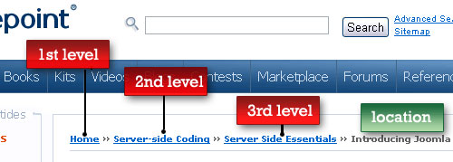

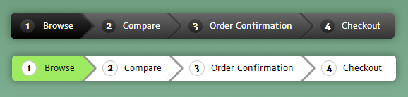

Fig 1 & 2. Examples of “Breadcrumb Trails”

Interestingly termed as “Breadcrumb Trails” (Hansel and Gretel reference), it is a secondary navigation scheme which displays the user’s current location in a website or web application. Breadcrumbs can be particularly useful if there is a large amount of content on a web page, or in web applications where there are multiple steps in achieving a user goal. Users would now have a way of tracing their paths back to their original start point.

Match between System and Real World

Rather than using system-oriented terms, a system should always speak the user’s language, whereby familiar words, phrases and concepts are used for system-user interaction. An example of system-oriented terms would be acronyms. It should not be assumed that the user knows what each and every acronym represents.

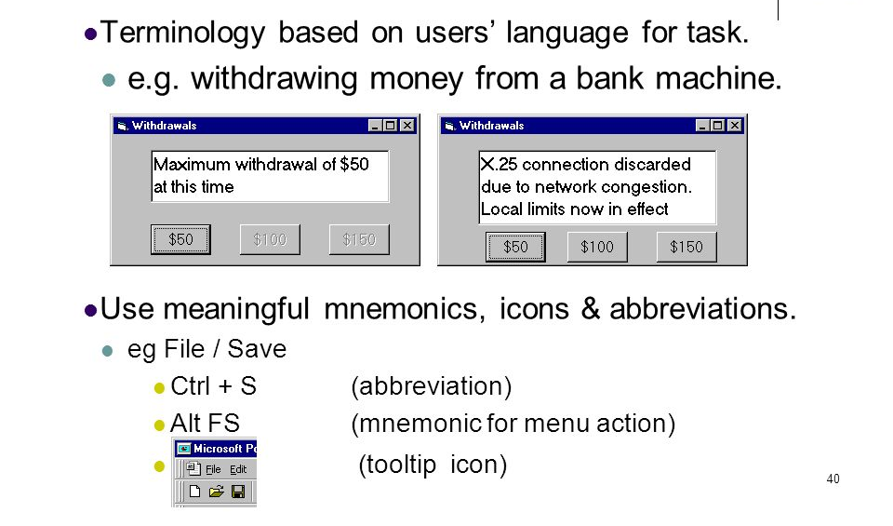

Fig 3. Example of match between system and real world

The image above is a very good example of what is discussed in this context. On the left window (“Minimum withdrawal of $50 at this time”) is where the system speaks the user’s language, which seems like it could be easily understood by any literate user, while the right window (“X.25 connection discarded due to network congestion. Local limits now in effect”) is something that may not be understood by most users, but the system instead.

Related Web UI Control

There is no relevant Web UI control for this aspect.

User Control and Freedom

During the user’s experience with a web site, he or she should be able to have maximum control over it. Should a user become lost and lack the ability to return to where he or she was, it will cause frustration and confusion, which is one of the least desirable outcomes of user interface utilization.

One example will be the Shopping Cart function found on most e-Commerce sites. Most customers are able to remove individual items from their cart, instead of having to reset their Shopping Cart and forgoing the remaining items that they may still want, and then adding them back again. After the removal of an unwanted item, they are able to continue with their shopping.

Related Web UI Control

Pagination

Pagination divides a document into discrete pages, so that users will be able to select which page they would like to be on, therefore serving user freedom and control.

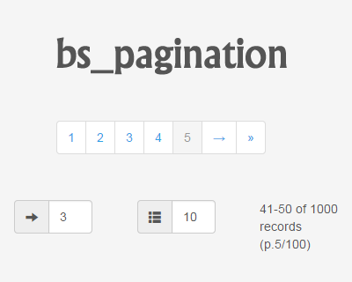

Fig 4. Example of a pagination navigation

Tags

In circumstances where there are large amounts of content found on a website, tags give users the benefit of finding content that is categorized under the same category. Some tagging systems even allow users to apply their own tags by entering them into the system.

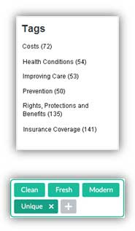

Fig 5. Example of tags that can be found on blogs

Consistency and Standards

No seamless user experience comes without the flow of consistency throughout a site. To make users feel like they are at a uniform location rather than teleporting to different corners of the internet, page-to-page navigation should be retained in terms of layout and style, at least. Putting aesthetics aside, it can be a confusing and distracting experience when web sites decide to use different terms for the same thing.



Fig 6. Example of a website practicing consistency

From the above example, we can see that the only difference between the home page and sub-page is the content. The design elements remain the same; the logo, navigation bar, the links, the color scheme used.

Error Prevention

“Prevention is better than cure”, this saying applies in this aspect. Good error messages are helpful, but what is even better is the prevention of a problem before it even occurs. How this can be done, is the elimination of error-prone conditions or check for them and provide users with a warning or confirmation option before they decide to execute the action.

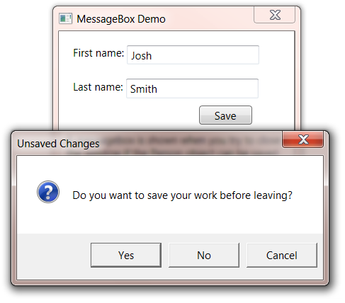

Fig 7. Example of error prevention

From the image above, let us assume it is a scenario where the user has accidentally closed the program he was currently on, and has unsaved progress. If not for this warning dialog “Unsaved Changes”, he would have lost all progress due his careless mistake.

Related Web UI Control

Message Box

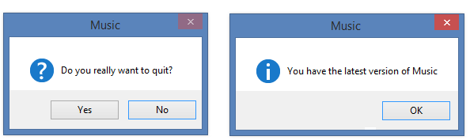

Fig 8. Example of message boxes

The baseline of message boxes is that they are small windows which display information to users and require a sort of confirmation before users can move on to the next action. This means that message boxes do not necessarily have to be warning dialogs all the time (like the Music window on the right of Fig 8.).

Recognition rather than Recall

It is a proven fact that humans are more efficient at performing memory recognition than memory recall. This is an important consideration when it comes to usability design; users should not be expected to recall the current page they on, or how they ended up there in the first place, especially if the user has spent a reasonably long duration on a single page. Guidance for navigation should always be visible or easily retrievable whenever appropriate.

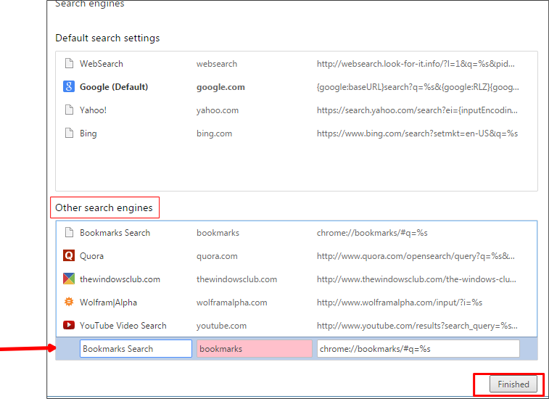

Fig 9. Example of search engine browsing history

One example of how “Recognition rather than recall” can be implemented in user interfaces is enabling the visibility of browsing history and previously visited content. This gives users ease in picking up on where they previously left, as some users do have difficulty recalling pages that they have recently visited, or searches performed in the near past.

Related Web UI Control

Breadcrumbs (Previously explained)

Flexibility and Efficiency

The flexibility of a web site can directly impact how the efficiency of use for the user. A site should to this aspect with a wide range of skills sets, be it to advanced, experienced or inexperienced users.

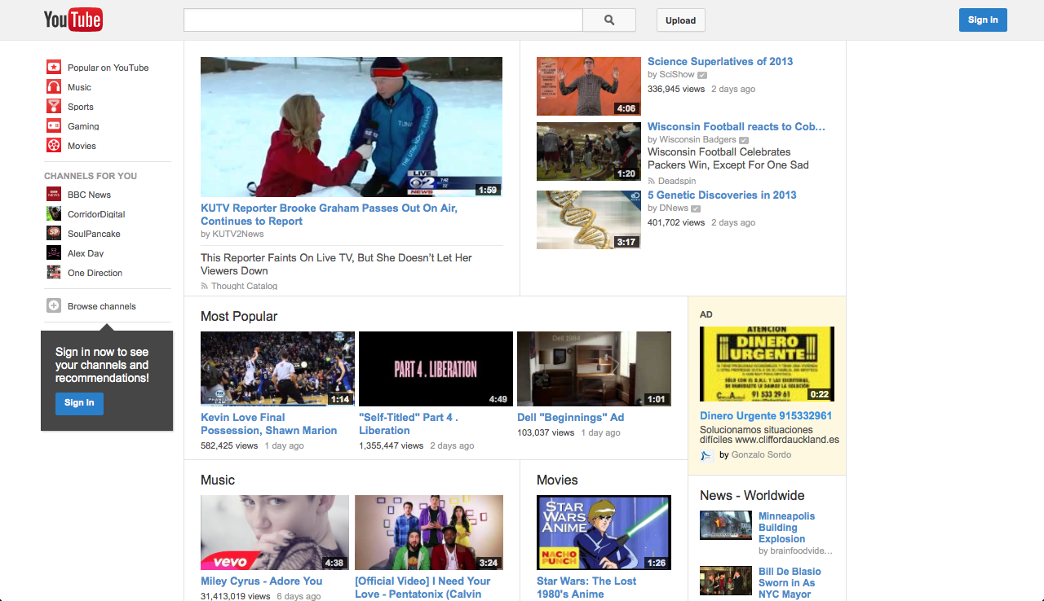

Fig 10. Page that a new user to YouTube would be viewing when browsing the site

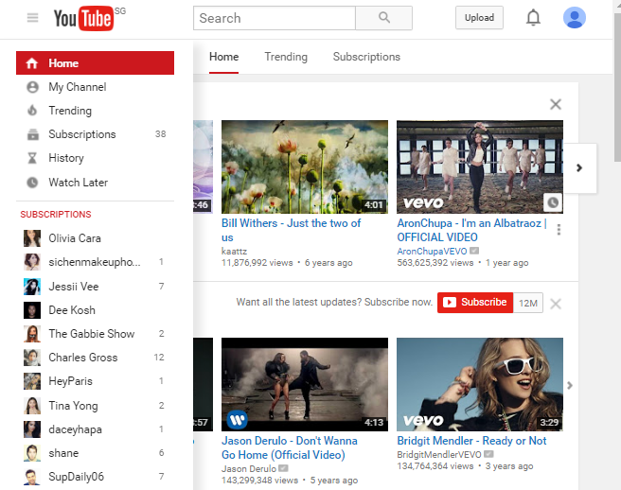

Fig 11. Page that an experienced or advanced user to YouTube would be viewing when browsing the site

Flexibility and efficiency can be achieved with the engagement of a particular user in a personal way, allowing an immediate connection between the user and his or her past history with the site. An example would be through the use of a log in function, which would deliver a personalized experience that can impede efficient browsing for users. YouTube is one example, where new users are able to navigate with flexibility and efficiency (refer to fig 10: Some features include “CHANNELS FOR YOU”, “Popular on YouTube”), and experienced users are not only able to view their past history with the site (refer to fig 11, where on the bar on the left indicates “History”), and also manage familiar personalization with the site (refer to fig 11, where the bar on the left lists all the YouTube subscriptions of the user).

Related Web UI Control

There is no related web UI control.

Aesthetic and Minimalist Design

Any redundant or irrelevant information should be left out in dialogs to avoid “slow-downs” and distractions to users, as extra information like this can interfere the relevant units of information and diminish their relative visibility.

Related Web UI Control

Tool Tips

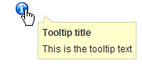

Fig 12. Example of a tool tip

Tool tips gives users the visibility of hints when they hover their cursor over a particular item indicating the name or purpose of the item. Since the information would only show if the user needs it, clutter in irrelevant or unnecessary information are hidden, therefore contributing to a simple, minimalist web interface.

Aid in Recognizing, Examination and Recovery from Errors

This may be a little similar to one of the heuristics discussed earlier (Error Prevention), but this focuses on the providing a solution to encountered errors. Error messages should be expressed in readable formats, which means the avoidance of codes, precisely identify the root cause of the problem, and then constructively suggest a solution.

Related Web UI Control

There is no related web UI control.

Help and Documentation

It is always helpful for users if there is a clear and robust set of help documentation available on a web site, even though it is better if the system was used without documentation. When users do require such help or documentation, it should be easy to search, focused on the user’s task, and list concrete steps to be executed.

Related Web UI Control

Quick Tip

These may seem similar to “Tool Tips”, that was previously mentioned in the Aesthetic and Minimalist Design heuristic, but quick tips are actually fully formatted messages which are usually presented in a modeless dialog.

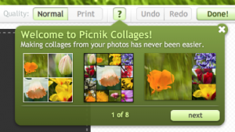

Fig 13. Example of Quick Tip utilized by a photo editing web site

PROGRAM DESIGN
This section of the Design Specifications states how the system is designed (the skeleton of the system). It will list the Use Cases of the system, it’s View of Participating Classes (VOPC) and sample forms.

Room Availability and Booking Module
There are 3 actors and 7 actions (it includes payment as a sub module)
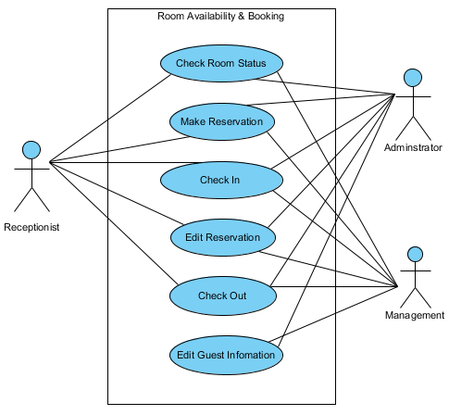
 | Check Room Status
To check if the type of room that the guest wish to stay in is available | - Receptionist  - Management of the hotel  - Administrator (Mr. Wang)

 | Make Reservation
To help the guest reserve a room. Receptionist’s job. But accessible by management and administrator. | - Receptionist  - Management of the hotel  - Administrator (Mr. Wang)

 | Check In
To help guests check into their room. Receptionist’s job. But accessible by management and administrator. | - Receptionist  - Management of the hotel  - Administrator (Mr. Wang)

 | Edit Reservation
To edit any booking of the rooms. Receptionist’s job. But accessible by management and administrator. | - Receptionist  - Management of the hotel  - Administrator (Mr. Wang)

 | Check Out
To help guests check out of their room. Receptionist’s job. But accessible by management and administrator. | - Receptionist  - Management of the hotel  - Administrator (Mr. Wang)

 | Edit Guest Information
Amend the guest table | - Receptionist  - Management of the hotel  - Administrator (Mr. Wang)

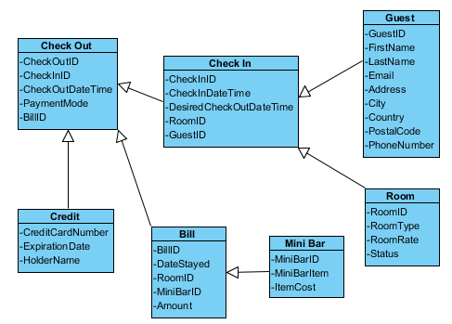

Housekeeping and Staff Management
There are 3 actors and 3 actions.
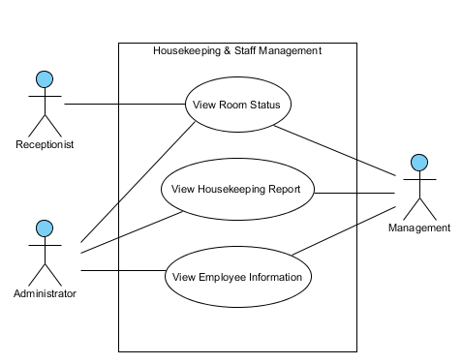
 | View Room Status
To check if the room is occupied, vacant or schedule for cleaning. | - Receptionist  - Management of the hotel  - Administrator (Mr. Wang)

 | View Housekeeping Report
To see which duty each employee is assigned to (General maintenance, Room maintenance, Estate maintenance or Security) | - Management of the hotel  - Administrator (Mr. Wang)

 | View Employee Information
To have access to the employee table and view them | - Management of the hotel  - Administrator (Mr. Wang)
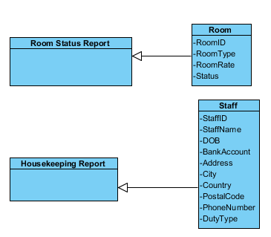
User Management
There is only 1 actor and 4 actions
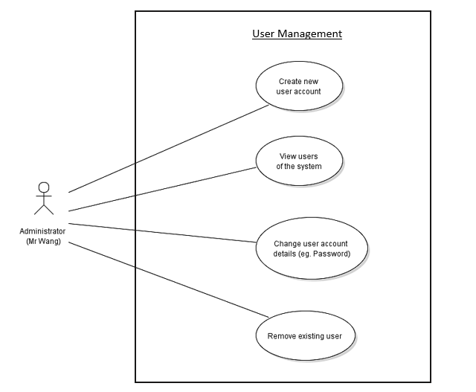
 | Create New User Account
To add a new staff into the employee table and also a new staff account. | - Administrator (Mr. Wang)

 | View Users of the System
Able to manage and oversee the whole system. Can have access / retrieve all information of the system, even staff and guest records | - Administrator (Mr. Wang)

 | Change User Account Details
Able to edit information from the system’s database | - Administrator (Mr. Wang)

 | Remove Existing User
Able to remove existing employee and guest from system’s database | - Administrator (Mr. Wang)

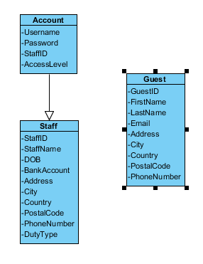
Report Module
There are only 3 actors and 5 actions
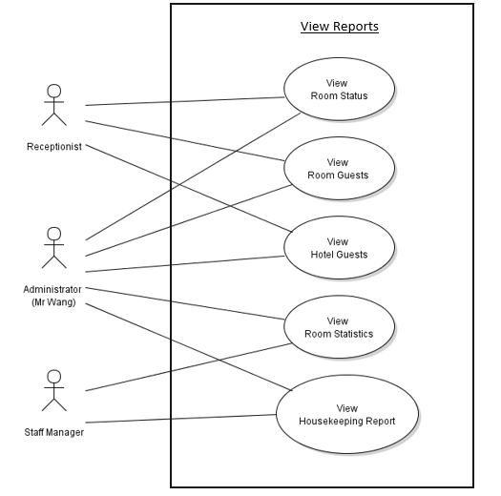
 | View Room Status
To check if the room is occupied, vacant or schedule for cleaning. | - Receptionist  - Management of Hotel  - Administrator (Mr. Wang)

 | View Room Guest
To view all the guests that are staying in one room | - Receptionist  - Management of Hotel  - Administrator (Mr. Wang)

 | View Hotel Guest
To view all the guests that are staying in the hotel on a specific date | - Receptionist  - Management of Hotel  - Administrator (Mr. Wang)

 | View Room Statistics
To have a gauge on how the room occupancy is like with statistics | - Manager of Hotel  - Administrator (Mr. Wang)

 | View Housekeeping Report
To see which duty each employee is assigned to (General maintenance, Room maintenance, Estate maintenance or Security) | - Management of Hotel  - Administrator (Mr. Wang)

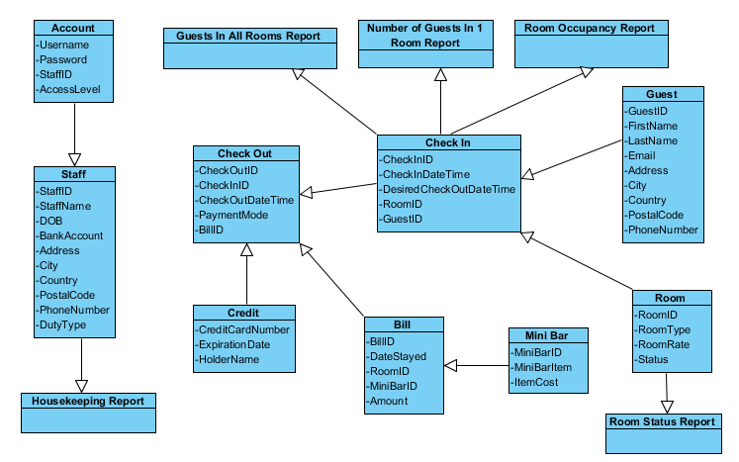
Sample Form
This sections shows a sample booking form that the receptionist will see when using the system.
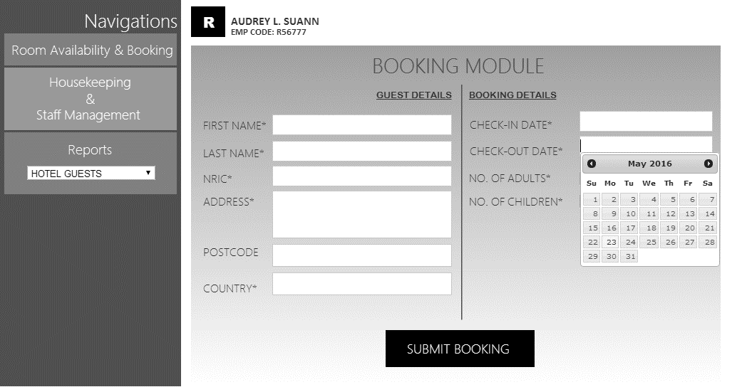

DATABASE DESIGN
We will be using Microsoft SQL to store the database in, to minimize data storage; Some tables are seperated to prevent repeat of data or dull data types as it isn’t necessary always filled. For example, MINIBAR table, it is not very frequent that guest will eat from the minibar, so I’ve separate it from the CHECKOUT table. CREDIT is also separated from CHECKOUT table, as some people might use cash to pay and credit card information will be left null, which cause empty field. BILL is separated from CHECKOUT table as I would want BILL to be a separate table for easy extraction. VARCHAR is used for most datatype as it is able to store variable length of alphanumeric data, while CHAR is not used as it has to be a string of fixed length, means that when I put firstName to be CHAR(10) they must put 10 characters no matter how short their name is, this causes inflexibility in name usage, as some name need not be so long. With VARCHAR this is possible as it is able to store a variable length of alphanumeric data. For postalCode, I’ve limited it to 10 only as, I’ve searched that the maximum number for a country’s postal code is 10. For phone number it is also up till 15 as I’ve found that the max number for phone is 15. For the rest of the data type limit, is by assumption.
Entity Diagram

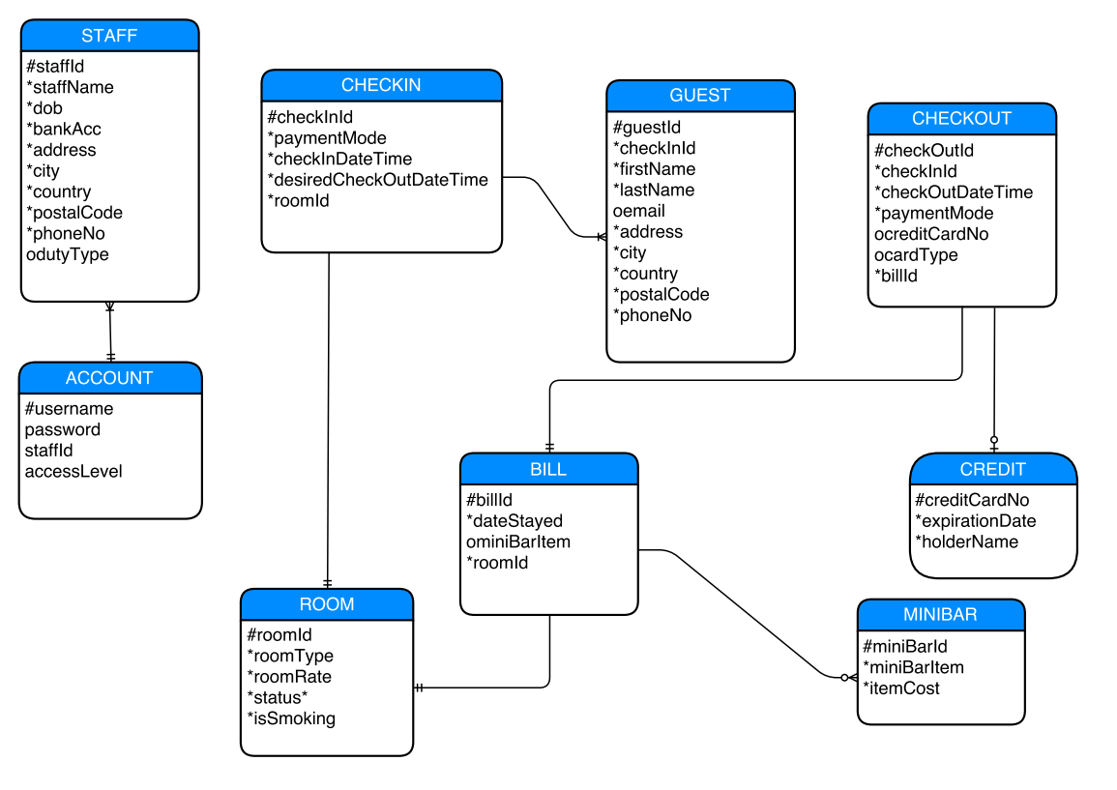

Database Schema
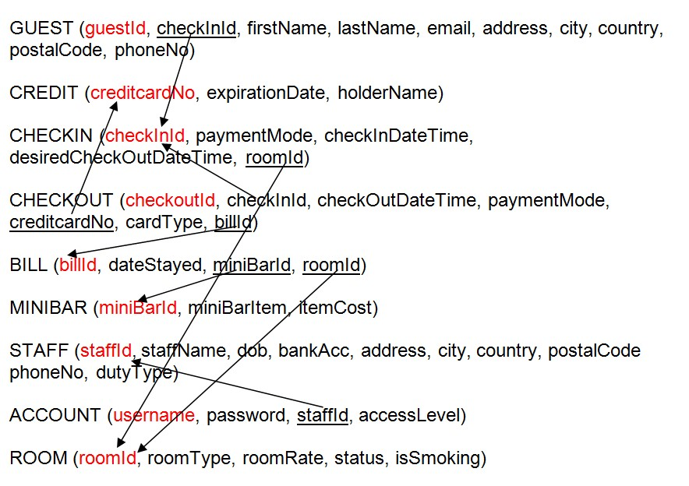

Legend
red = primary key
underlined = foreign key
Database Dictionary
 |  | Table Name: CHECKOUT
Table column Name | Table column Datatype | Table Column Null Option | Table Column Comment | Table Column is PK | Table Column is FK
checkoutId | Int(8) | Not null |  | YES | NO
checkInId | Int(8) | Not null |  | NO | YES
checkOutDateTime | Datetime() | Not null |  | NO | NO
paymentMode | Text(6) | Not null |  | NO | NO
creditcardNo | Int(19) | Null |  | NO | YES
cardType | Text(20) | Null |  | NO | NO
billId | Int(8) | Not null |  | NO | YES

 |  | Table Name: CHECKIN
Table column Name | Table column Datatype | Table Column Null Option | Table Column Comment | Table Column is PK | Table Column is FK
checkInId | Int(8) | Not null |  | YES | NO
paymentMode | Text(6) | Not null |  | NO | NO
checkInDateTime | Datetime() | Not null |  | NO | NO
desiredCheckOutDateTime | Datetime() | Not null |  | NO | NO
roomId | Int(8) | Not null |  | NO | YES

 |  | Table Name: GUEST
Table column Name | Table column Datatype | Table Column Null Option | Table Column Comment | Table Column is PK | Table Column is FK
guestId | Int(8) | Not null |  | YES | NO
checknId | Int(8) | Not null |  | NO | YES
firstName | Varchar(40) | Not null |  | NO | NO
lastName | Varchar(40) | Not null |  | NO | NO
email | Varchar(40) | Null |  | NO | NO
address | Varchar(40) | Not null |  | NO | NO
city | Varchar(50) | Null |  | NO | NO
country | Varchar(40) | Not null |  | NO | NO
postalCode | Int(10) | Not null |  | NO | NO
phoneNo | Int(15) | Not null |  | NO | NO

 |  | Table Name: ROOM
Table column Name | Table column Datatype | Table Column Null Option | Table Column Comment | Table Column is PK | Table Column is FK
roomId | Int(8) | Not null |  | YES | NO
roomType | Varchar(15) | Not null |  | NO | NO
roomRate | Decimal(18,0) | Not null |  | NO | NO
status | Varchar(20) | Not null |  | NO | NO
isSmoking | Varchar(5) | Not null |  | NO | NO

 |  | Table Name: CREDIT
Table column Name | Table column Datatype | Table Column Null Option | Table Column Comment | Table Column is PK | Table Column is FK
creditCardNo | Int(20) | Not null |  | YES | NO
expirationDate | Date(8) | Not null |  | NO | NO
holderName | Varchar(40) | Not null |  | NO | NO

 |  | Table Name: BILL
Table column Name | Table column Datatype | Table Column Null Option | Table Column Comment | Table Column is PK | Table Column is FK
billId | Int(8) | Not null |  | YES | NO
dateStayed | Int(10 | Not null |  | NO | NO
miniBarId | Int(8) | Null |  | NO | YES
roomId | Int(8) | Not null |  | NO | YES

 |  | Table Name: MINIBAR
Table column Name | Table column Datatype | Table Column Null Option | Table Column Comment | Table Column is PK | Table Column is FK
miniBarId | Int(8) | Not null |  | YES | NO
miniBarItem | Varchar(20) | Not null |  | NO | NO
itemCost | Decimal(18,0) | Not null |  | NO | NO

 |  | Table Name: STAFF
Table column Name | Table column Datatype | Table Column Null Option | Table Column Comment | Table Column is PK | Table Column is FK
staffId | Int(8) | Not null |  | YES | NO
staffName | Varchar(40) | Not null |  | NO | NO
dob | Date() | Not null |  | NO | NO
bankAcc | Int(20) | Not null |  | NO | NO
address | Varchar(40) | Not null |  | NO | NO
city | Varchar(50) | Null |  | NO | NO
country | Varchar(40) | Not null |  | NO | NO
postalCode | Int(10) | Not null |  | NO | NO
phoneNo | Int(15) | Not null |  | NO | NO
dutyType | Varchar(20) | Null |  | NO | NO

 |  | Table Name: ACCOUNT
Table column Name | Table column Datatype | Table Column Null Option | Table Column Comment | Table Column is PK | Table Column is FK
username | Varchar(20) | Not null |  | YES | NO
password | Varchar(20) | Not null |  | NO | NO
staffId | Int(8) | Not null |  | NO | YES
accessLevel | Varchar(20) | Not null |  | NO | NO

Entity Diagram

